 | 
The Cute Challenge Cup
Comparative Grammar Adventure
Reading Text
Jennie is at the Cute Challenge Cup with two little animal friends: Coco the cat and Momo the bunny. They want to win a fun prize: a shiny star badge!
Coco is small, but she is faster than Momo. She can run quickly through the ribbon tunnel. Momo is taller than Coco and can jump higher over the soft blocks.
The next game is the giggle race. Momo makes funny faces, but Coco is funnier. Everyone laughs when Coco wears a tiny purple hat!
At the last station, they work together. Momo is more careful with the puzzle pieces, and Coco is more excited about the prize. In the end, they learn that being kind is more important than being first.

Vocabulary
Match the word to its meaning. Write the correct letter on each line.
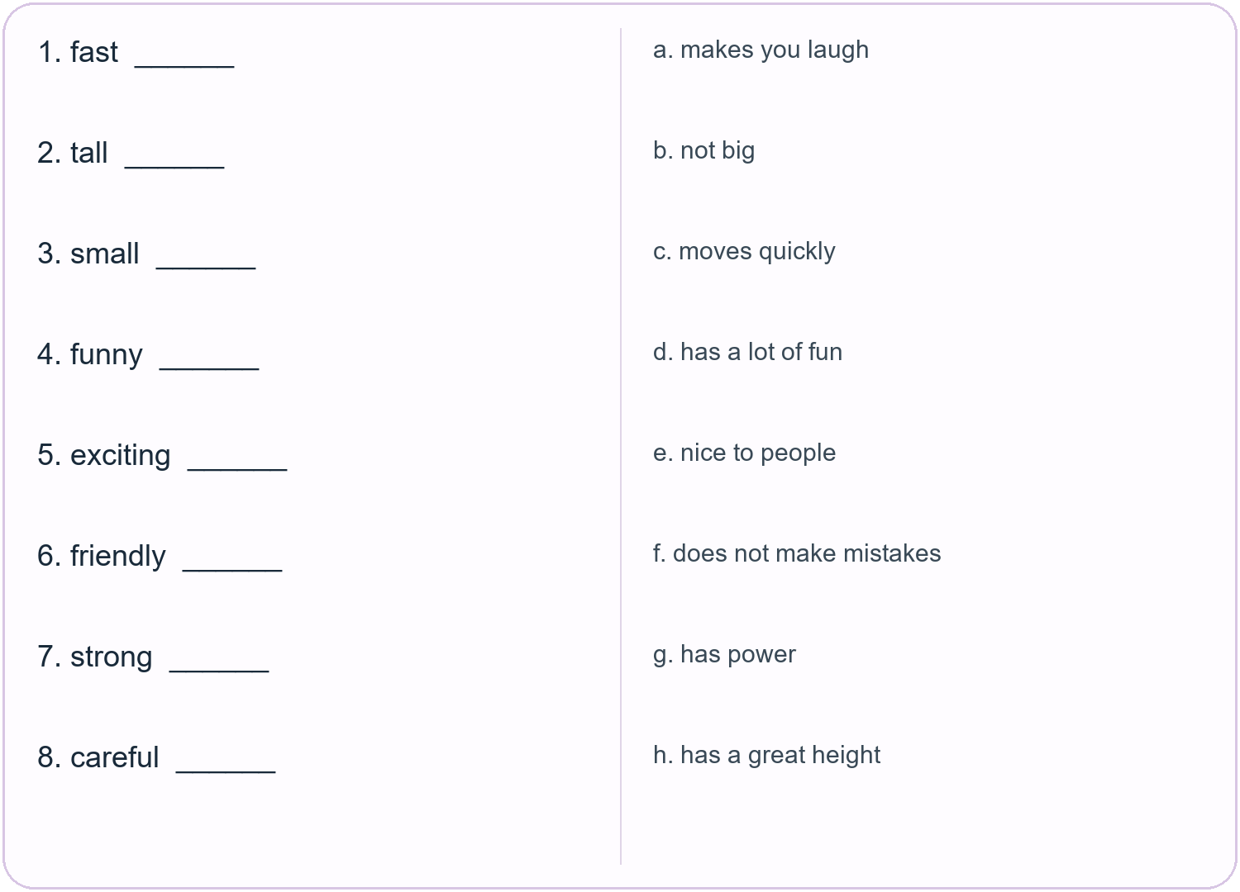

Short Answer Questions
Answer in short sentences.
1. Who are the two animal friends?
____________________________________________________________________________
2. Who is faster?
____________________________________________________________________________
3. Who is taller?
____________________________________________________________________________
4. Who is funnier?
____________________________________________________________________________
5. What can Momo jump over?
____________________________________________________________________________
6. What is Coco more excited about?
____________________________________________________________________________
7. What is more important than being first?
____________________________________________________________________________

Grammar Focus Comparatives
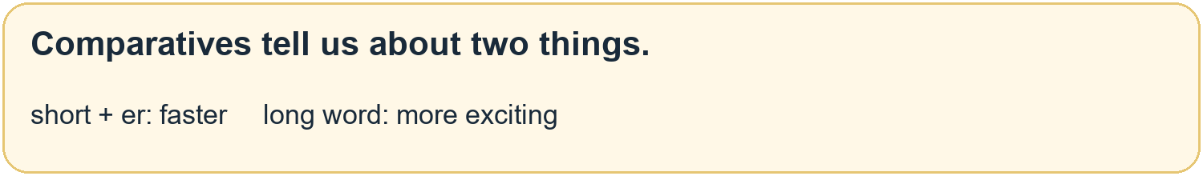
A. Circle the correct word.
1. A rabbit is fast / faster than a turtle.
2. A giraffe is tall / taller than a cat.
3. Coco is funny / funnier than Momo.
4. This game is more exciting / exciting than homework.
5. Momo is careful / more careful than Coco.
B. Write your own sentences.
1. A cat is __________________ than a mouse.
2. My friend is __________________ than me.
3. A __________ is more __________ than a __________.

My Challenge Friends
Creative Drawing
Creative Drawing
Draw two cute friends for the Challenge Cup!
Include: two characters • one race or game • one prize • one comparison
Friend A is: _________________________________
Friend B is: _________________________________
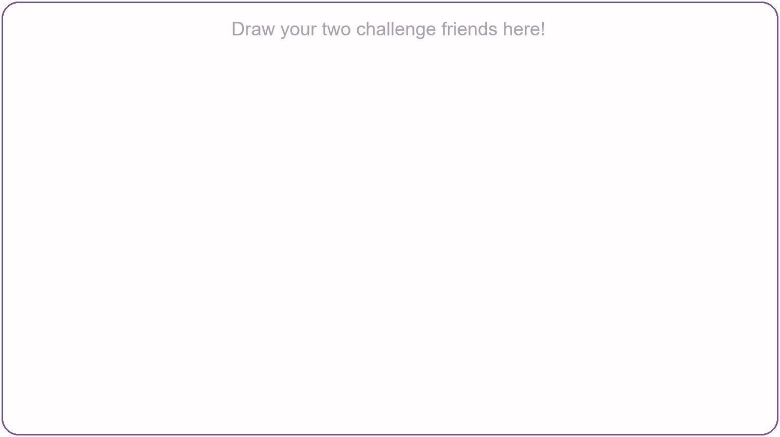
My sentence: _______________________________________________

